The Connection
Sunday, March 15, 2015

This Week at All Saints

Sunday, Mar 15th

8:45-9:45am Traditional Worship (Sanctuary)
10:00-10:45am Sunday School 5yr to 2nd Grade (CLC Room 12)
Sunday School 3rd to 5th Grade (Jr. High Rm)
Jr. High & Sr. High (Sr. Rm)
Adult Bible Study Class (Library)
10:15am New Membership Class (Counters Rm)
11:00-12:00pm Contemporary Worship (Sanctuary)
4:00-6:00pm Jr. High 4th thru 8th Grade (Jr. Rm)
5:00-7:00pm Sr. High (Sr. Rm)

Wednesday, Mar 18th
We are grateful to God that he directed you here and we pray that you are blessed by your worship experience. Practicing His presence through worship is one of the most valuable things we can do. God has promised that as we draw near to Him, He will draw near to us and we will experience His presence in ever increasing measures.
We have a gift for you at the Visitor’s Table. Please accept this tote bag as our gift of appreciation and be sure to pick up a calendar.

9:30-11:00am Shalom Bible Study (Counters Rm)
6:15pm Lenten Dinner
5:15-6:15pm First Communion Instruction (Pastors Office)
7:00-8:00pm Lenten Service
Divorce Care Support Group (Prayer Rm)
Chancel Choir Rehearsal (Choir Room)

Thursday, Mar 19th

8:45am Ladies Breakfast
7:00-9:00pm Council Meeting (Library)
Flowers are wonderful way to remember a loved one or celebrate a birthday.
Signup at the Worship table
in the Atrium.

7:00-9:00pm Praise Team Rehearsal (Sanctuary)

Saturday, Mar 21st

7:00-9:00pm COFFEE HOUSE MUSIC

Sunday, Mar 22nd

8:45-9:45am Traditional Worship (Sanctuary)
10:00-10:45am Sunday School 5yr-2nd Grade (CLC Rm 12)
Sunday School 3rd to 5th Grade (Jr. High Rm)
Jr. High & Sr. High (Sr. Rm)
10:15am TOWN HALL MEETING (Fellowship Hall)
11:00-12:00pm Contemporary Worship (Sanctuary)
3:00pm Confirmation Class (Jr. Rm)
4:00-6:00pm Jr. High 4th thru 8th Grade (Jr. Rm)
5:00-7:00pm Sr. High (Sr. Rm)

All Saints Lutheran Church Finance Report for December and Year End 2014

 | December, 2014 | Year End 2014
Receipts (offerings & misc.) | 51,338.58 | 384,548.05
Expenses | 37,598.15 | 370,926.79
Receipts over Expenses | 13,740.43 | 13,621.26

All Saints has finished the 2014 year in a good financial position. With good stewardship, All Saints has used the gifts that God has provided to keep the church financially stable as well as to provide local benevolence. As we look forward to 2015, we face challenges with the budget as we continue to build our youth ministry and maintain our facility. We realize that our financial gifts are very important but we must never forget that as Disciples of Christ, we can give of our time as well. As we read in Romans 12:3-8, “we have different gifts, according to the grace given us.”

As we enter the Lenten season, we are reminded what Jesus Christ has sacrificed for us. How can we ever repay that debt?? Jesus reminds us in Matthew that “whatever we do to the least of these, you have done unto me.” We pray that all members of the body at All Saints will use their “gifts” in some way to help the “least of these”. All Saints does provide ministries in which each and every one can be involved to help at All Saints as well as in the community. Little things like making sandwiches for the life shelter, or ushering, or quilting, or putting images on the big screen for Sunday morning worship or helping to organize food donations for the community— all are done to help one another. A small sacrifice of our time – a thought as we look forward to Easter.

Respectfully Submitted,
David Gustafson - Treasurer

Shalom Bible Study

Meets Wednesday, March 18th
9:30am
Join Us!

Ladies Meet for breakfast
Thursday, March 19th at 8:45am
At the Corner Bakery on
South Cooper St.

Do you have a lucky number? Would you like to donate to our Easter Eggstravaganza or help fund our Good Friday play, In His Footsteps, but don’t have a lot to give? Look for the envelope board in the atrium and choose an envelope whose number corresponds with the amount of money that you would like to donate. Take that envelope, place your donation in it, sign it, and place it in the box. No donation is too small to help with our outreach and it’s easy too!

Church
Council Meeting
Thursday,
March 19th
7:00pm
Coffee Fellowship

There is a sign up posted at the Coffee Bar for volunteers to help with this ministry on Sunday mornings. Sign up today!

We are a Stephen Ministry Congregation!
Are you a good listener...or...do you sometimes wish you just had someone to talk to? Stephen Ministry is a confidential Christian care-giving ministry that can serve the needs of our All Saints family members in times of difficulty. To learn more of what Stephen Ministry is all about visit the Relationship table and contact:
Lynn Gustafson at 817-563-2340

Adult Bible Study

Sunday’s at 10:00am
Lenten Studies
Join us for our third Lenten study entitled:
“Temptation”

Chancel Choir
Rehearsal
Wednesday,
Mar 18th
After service

Lenten Dinners will be served at 6:15pm before each Wednesday evening service.

March 18 – Outreach & Communications will serve.

March 25 – Property will serve.

For your convenience childcare is provided for both services and Sunday school. Children age 4 and under.

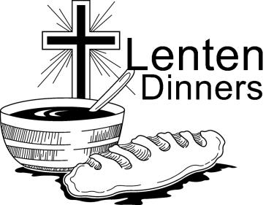

Thank you!
Never underestimate the power of your prayers. It is my privilege to frequently praise and thank our Heavenly Father for you. He received your prayers as incense and responded with His healing grace through a perfect hip surgery and timely recovery. Of my three surgeries in five years this has been the easiest and smoothest. I am doing so well.
Thank you to Pastor John for your prayers, visits, calls, and excellent shepherding.
Thank you to all you Prayer Warriors for your awesome support in prayers, cards, and phone calls.
And a public Thank You to my dear Carmen who had no idea what was in store when he said, “I do”, 45 years ago.
United in Christ’s love and His Spirit,
Lucie Priola

WE WANT YOUR POP TABS!
The Collection House can be found on the coffee bar in the Atrium. Pop tabs support the Ronald McDonald House in Fort Worth!

During both the 8:45am & 11:00am services your children are invited to step out during the sermon and learn about God’s love for them on their level. Children’s Church is aimed at students 5yrs to 3rd grade. They’ll return in time to join you for communion. Children are always welcome to stay in with their parents during the sermon.

Children’s Learning Center
Open Registration

Registration for the 2015-16 school term is ongoing and now open to the public. Classes fill on a "first come, first served" basis. The registration-supply fee is due at the time of registration to hold the child's spot. Hours of operation and pricing, including fee schedule, can be found at http://www.clclearning.org
Or by calling the CLC office at (817) 483-6692

Feb. 15th thru April 5th “Back to the Basics”
10:10am between services

Sunday, Mar 15
What Makes Lutheran Christianity Unique?
Sunday, Mar 22
All Saints’ Organization, History, and Staff Adult & High School - Lutheran – Flavored Christianity: Law & Gospel
Sunday, April 5th Easter Sunday
New Members Reception - between services.

Divorce Care
Wednesday nights
7:00pm
Healing from divorce is not easy. At DivorceCare groups, people in separation and divorce find tools teaching and support to help them deal with their pain and give them hope for the future. For more info see Greg and Ruby Gearing or call the church office: 817-483-1631

VOLUNTEERS NEEDED

It is with much excitement that All Saints prepares to again perform “In His Footsteps”. This is a play about the life of Christ and a great opportunity to share the good news with others. We will need “actors” for the characters, singers for the songs scattered through to play, backstage and scene help as well as greeters.
The signup sheet is on the table in the atrium. Please say yes when asked to help us with this great outreach opportunity. The play will be done April 3rd, Good Friday evening. If you have any questions please call Robin Evans at 817-992-5677 or Wendy Helke at 817-437-0402

1st Communion Instruction

A three-session course offered to 4th &5th graders
to prepare them to begin receiving communion at All Saints.

Session One: March 18, 5:15 – 6:15pm
(Note that we skip the week of March 11!)

Session Two: March 25, 5:15 – 6:15pm
​First Communion is then offered on Maundy Thursday, April 2, 2015, at the evening service.
If interested speak with Pastor John, Kyle Jones, or call the office at 817-483-1631

Celebrate the Resurrection with us by filling the empty space above the doors leading into the Worship Center with crosses! If you have crosses of any shape or size that you would like to donate please tag them with your name and bring them to the church office or give to Glen or Carol Foster

It’s time once again to form teams to mow the church grounds and park thru the summer season. If you can volunteer please sign up at the activities table in the Atrium or see Glen Foster

Town Hall
Meeting Scheduled

We will be hosting a Town Hall meeting on Sunday, March 22nd from 10:15 to 10:45 in the Fellowship Hall to present budget revisions to a fund full time youth and family ministry position. The sixth and final new members’ class will be moved to Palm Sunday to accommodate.

Lenten Offerings

The offerings received on Wednesday nights thru Lent will be sent to Arlington Charities and Union Gospel Mission.

Easter Lilies
Sign up in the Atrium. Please print your name, the number of flowers you are requesting and the dedication you wish to make (in memory or in celebration of someone special). Flowers are $10.00ea.
Please write “Easter Lilies” on your check memo line.

We are preparing and planning our annual Easter Eggstraveganza.
On Saturday, March 28th
10-12:00pm
We need wrapped candy, and volunteers to help stuff plastic eggs with candies and to boil the eggs to be decorated. Also volunteers to hand out information during our community festival.
This is an opportunity for All Saints to demonstrate the love of God to our community. We will be needing volunteers to assist with every event. Please sign up in the Atrium.
If you can help please contact:
Robin Evans 817-992-5677 or Wendy Helke 817-437-0402

Remember to bring your
Fresh flowers to decorate
The cross in the Atrium on
Easter Sunday!

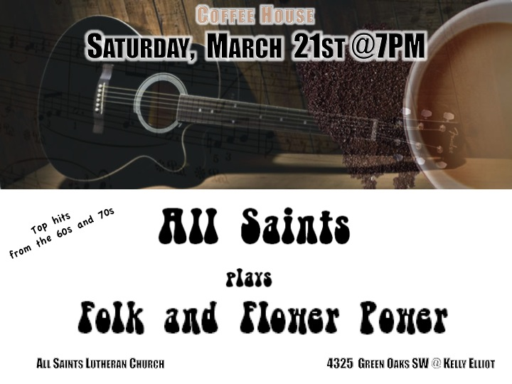

A big Thanks to everyone, who worked on and came to eat, bid and contributed to the Spaghetti Dinner, Silent and Dessert Auction. You helped make our fund raising a success.

Rehearsal
Thursday,
March 19th 7:00pm

Easter Breakfast Casserole Potluck

Sunday, April 5th 10-11:00 between services

We invite our new members to join us and participate in the potluck. Please bring your favorite breakfast casseroles, breakfast breads/pastries/muffins or fruit to share. All please sign up at the Activities table in the atrium so we know what you will be bringing.

The Spring Clean Up Day will be Saturday, March 21st
9:00-12:00pm. Please come and help us with clean up inside & out. Signup sheet in the Atrium.

Lutheran World Relief Quilters
Blessing of the Quilts
Sunday, March 22nd

Our Quilters have been fruitful and busy this year and as we bless the fruit of their hands on March 22nd we ask everyone to help this worthy cause by donating toward the purchase of supplies, material and the cost to ship them. The quilters made large quilts and baby quilts this year.

There are quilts and baby quilts on the pews next Sunday.
The large quilts will go to the Lutheran World Relief to be sent around the world to help those in need and baby quilts will go to MCA Neonatal ICU.

The cost is $2.50 per quilt to ship the quilts to LWR. Designate your donations on the offering envelope for Relief Quilters. March 22nd you may purchase a handmade quilt and help buy supplies in the coming year. The batting we use cost us $79.00 a roll and 4-5 rolls are used a year. To purchase a quilt find a quilter after the service.

– $100.00 for a full size quilt – $40.00 for a baby quilt.

The Relief Quilters are: Anna Brennan, Carol Foster, Judy Heisel, Sherry Livingston, Lucy Priola, Alleen Stephenson, and Lavon Wirkler.

Senior High
Mission Trip

July 5th-11th, 2015
Ripely, TN | Cost: $447

If interested sign up at the youth table in the atrium

All Saints Lutheran Church
Those Who Serve Us Today
8:45 a.m. 11:00 a.m.
Greeters/Visitor Table: Jerry & Ann Terhune

Ushers: Aubry McManus
Tina McManus
Alex Widner Mearl Avis
Lavon Wirkler Glenn Shimek

Assisting Minister: Jerry Terhune

Lay Reader: Wendy Helke

Altar Guild: Marilyn Funderburk Sandi Vatthauer

Communion Assistants:
Anna Brennan– Wine Vicki Almos – Wine
Jerry Terhune- Wine Carol Cameron – Wine
John Barnes – Bread Curt Lewis– Bread
Pastor John– Bread Pastor John– Bread

Prayer Ministry: Lois Becker & Ann Terhune Sandi Vatthauer
Sound Techs- Steve Bessler, John Barnes
Video – Bill Stephenson
Media – Mary Rosas, Kristen Barnett, Shelby Barnett,
Beverly Byers, Alex Byers

Counters: Beverly Byers Kurt Webber
Coffee Servers: Deb Hanson/Kristen & Shelby Barnett
Nursery Care: Gabbi Inman & Garla Sims
Scrip Table: Fred & Pam Wendt Carol Foster

Staff
Pastor: Rev. John Scheusner
Director of Youth and Family Ministries Intern: Kyle Jones
CLC Director: Peggy Elder
Office Manager: Liz Beaty
Contemporary Music/Worship Coordinator: Hedreich Nichols
Choir Director/Accompanist: Joe Alan
Prayer Chain Coordinator:
Vicki Almos
Congregation Council Members
President: Marc Funderburk President Elect: John Viard Treasurer: Dave Gustafson
Treasurer Elect: Jim Kimble Secretary: Libby Lindstrom Secretary Elect: Katie Manquero
Trustee Board Chair: Doug Parker Ministry Board Chair: John Barnes

Congregation Committee Chairpersons
Fellowship: Open Finance: Dave Gustafson Communications: Greg Gearing Community/Member Care: Carol Foster Kitchen Coordinator: Mary Rosas
Outreach/Evangelism: Robin Evans Personnel: Open Property: Len Livingston
Worship Logistics Coordinator: Ann Terhune Youth and Family Ministry: John Viard
Church Office: 817-483-1631 Church Fax: 817-483-8731 Children’s Learning Center: 817-483-6692
All Saint’s Website: www.allsaintsarlington.org Address: 4325 SW Green Oaks Blvd., Arlington, TX 76017
NALC (North American Lutheran Church) Website: www.thenalc.org

