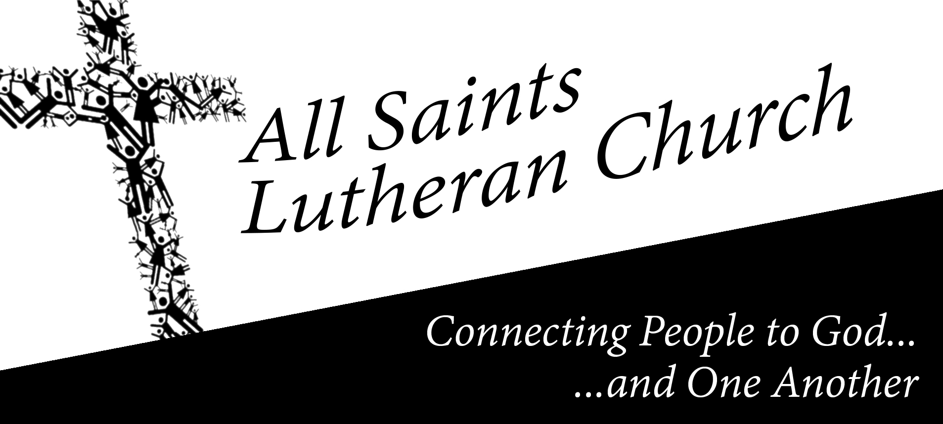
The Connection
Sunday, April 5, 2015

This Week at All Saints

Easter Sunday - Apr 5th

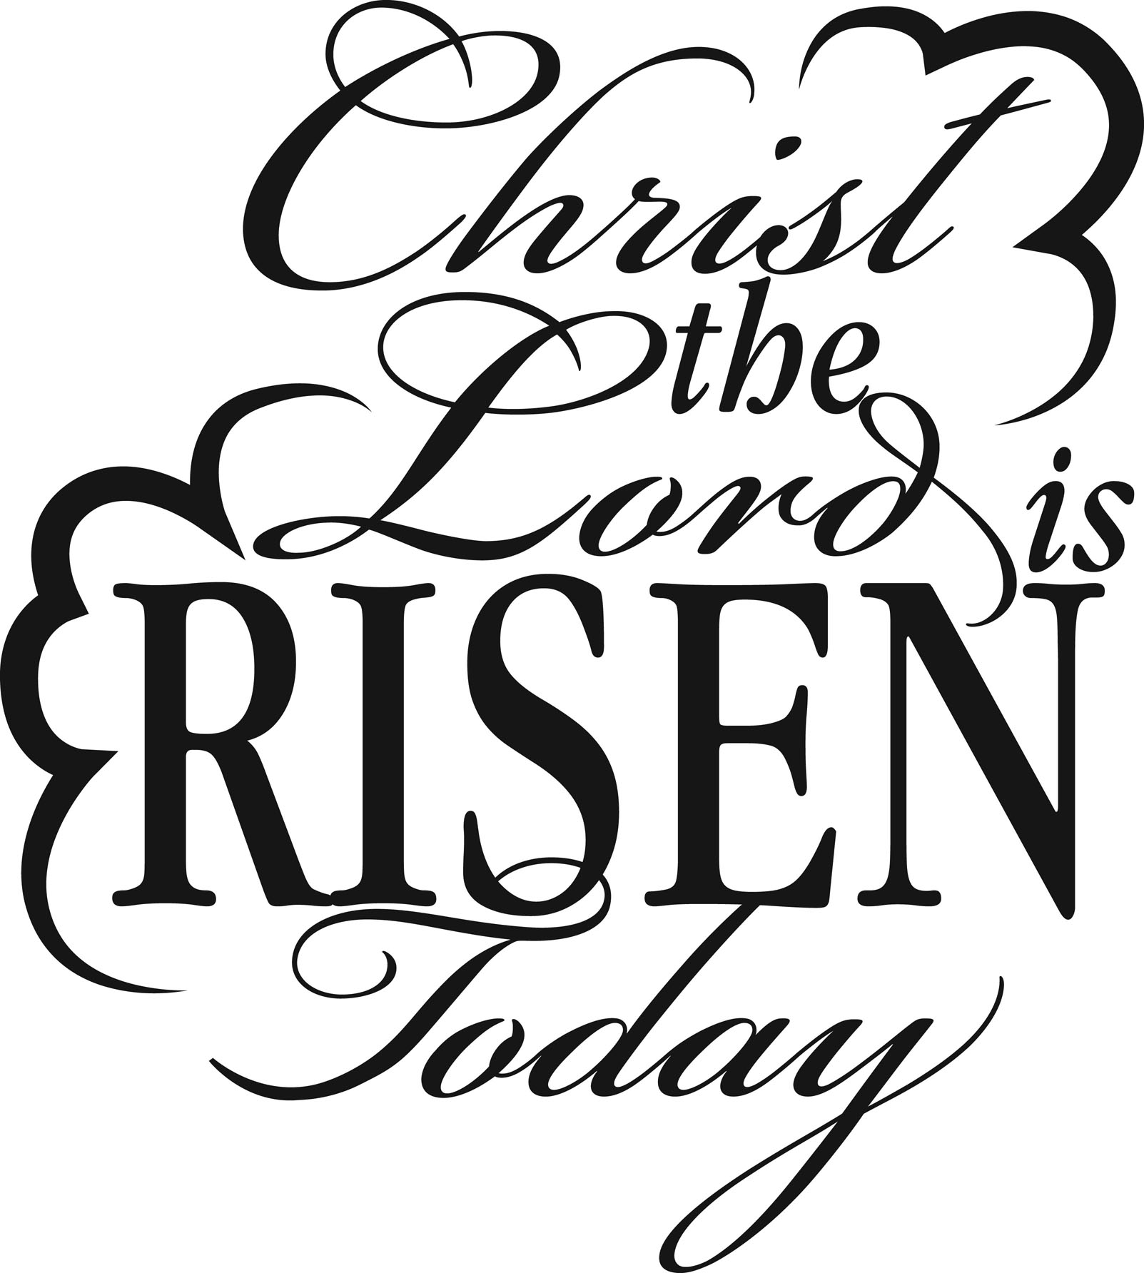
8:45-9:45am Traditional Worship (Sanctuary)
10:00-10:45am Easter Breakfast and New Members Reception
11:00-12:00pm Contemporary Worship (Sanctuary)

Monday, Apr 6th

7:00pm Divorce Care Support Group (Counters Rm)

Tuesday, Apr 7th

9:00am Relief Quilters

Wednesday, Apr 8th
We are grateful to God that he directed you here and we pray that you are blessed by your worship experience. Practicing His presence through worship is one of the most valuable things we can do. God has promised that as we draw near to Him, He will draw near to us and we will experience His presence in ever increasing measures. We have a gift for you at the Visitor’s Table. Please accept this tote bag as our gift of appreciation and be sure to pick up a calendar.

7:00pm Chancel Choir Rehearsal (Choir Room)

7:00pm Adult Bible Study (Library)

Thursday, Apr 9th

7:00pm Praise Team Rehearsal (Sanctuary)

Saturday, Apr 11th

8:00am Men’s Bible Study (Library)
6:00pm Coffee House Music at Stovall Park
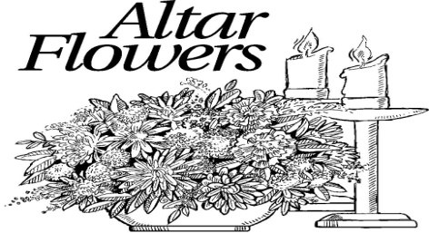
Flowers are wonderful way to remember a loved one or celebrate a birthday. Signup at the Worship table in the Atrium.

Sunday - Apr 12th

8:45-9:45am Traditional Worship (Sanctuary)
10:00-10:45am Sunday School 5yr-2nd Grade (CLC Rm 12)
Sunday School 3rd to 5th Grade (Jr. High Rm)
Jr. High & Sr. High (Sr. Rm)
Adult Bible Study Class (Library)
11:00-12:00pm Contemporary Worship (Sanctuary)
3:00pm Confirmation Class (Jr. Rm)
4:00-6:00pm Jr. High 4th thru 8th Grade (Jr. Rm)
5:00-7:00pm Sr. High (Sr. Rm)

For your convenience childcare is provided for both services and Sunday school. Children age 4 and under.

We are a Stephen Ministry Congregation!
Are you a good listener...or...do you sometimes wish you just had someone to talk to? Stephen Ministry is a confidential Christian care-giving ministry that can serve the needs of our All Saints family members in times of difficulty. To learn more of what Stephen Ministry is all about visit the Relationship table and contact:
Lynn Gustafson at 817-563-2340

Ladies Meet for breakfast
Thursday, March 19th at 8:45am
At the Corner Bakery on
South Cooper St.

Coffee Fellowship

There is a sign up posted at the Coffee Bar for volunteers to help with this ministry on Sunday mornings. Sign up today!

Adult Bible Study
Sunday’s at 10:00am
Next Sunday – “If you want to walk on water, you’ve got to get out of the boat.”

Divorce Care
NEW NIGHT - Monday nights
7:00pm
Healing from divorce is not easy. At DivorceCare groups, people in separation and divorce find tools teaching and support to help them deal with their pain and give them hope for the future. For more info see Greg and Ruby Gearing or call the church office: 817-483-1631

Rehearsal
Thursday,
April 9th 7:00pm

We will meet Tuesday, April 7th 9:00am

Lutheran World Relief Quilters Ministry
The Relief Quilters want to continue our Quilting Ministry and need your help. We need your support with cotton fabric donations, sewing of simple quilt tops and “tying” on Tuesday mornings. Most of all we need your prayers. If you would like to participate so that we can continue this ministry please contact any of our group for further information.

Carol Foster, Kathy Walk, Aleen Stephenson, Lavon Wirkler, Judy Helsel, Anna Brennan

Chancel Choir Rehearsal
Wednesday, Apr 8th
7:00pm

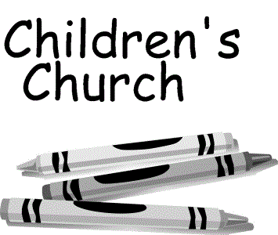

During both the 8:45am & 11:00am services your children are invited to step out during the sermon and learn about God’s love for them on their level. Children’s Church is aimed at students 5yrs to 3rd grade. They’ll return in time to join you for communion. Children are always welcome to stay in with their parents during the sermon.

Don & Marilyn Matson
Sharon Robison
Paul Schmiege
Patty Scott

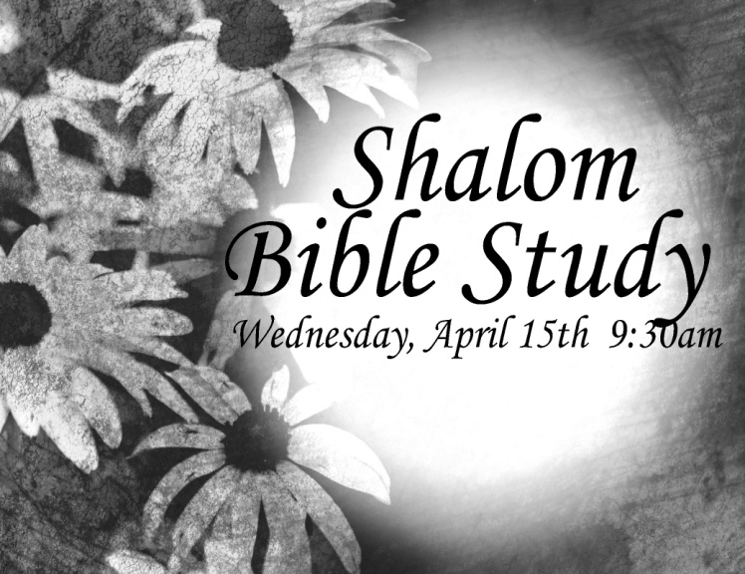

Lilies Provided By

Family Name Dedication

Beverly Byers In memory of parents

Jim and Jan Kimble In memory of our daughter Amber

Lavon Wirkler In memory of loved ones
John and Lucy Barnes In memory of our parents
Len and Sherry Livingston In thanksgiving for our family
Larry and Judy Helsel In memory of our parents
Marc and Marilyn Funderburk In memory of our parents
Glen and Carol Foster In memory of our parents
Ken and Rhonda Kiesling In memory of our family
Linda Stimel In memory of John Stimel, Frances Apel & Don Schnor
Bob & Linda Peterson In memory of our parents
Pam and Fred Wendt In memory of our family
Jay & Vicki Almos In memory of our parents
Jo Rabbers In memory of my parents
Greg & Ruby Gearing In memory of grandma Ruby
Myron & Carol Krueger In memory of Matthew
Lavon Wirkler In memory of loved ones
Kevin Hanson Family In memory of our parents
Stephen and Kim Jones In memory of Carol Jones
Gary and Dana Collins In memory of loved ones
Dave and Lynn Gustafson In memory of loved ones
John and Bettye Knopp In memory of loved ones
Aubry and Tina McManus In memory of loved ones
Sandi Vatthauer family In memory of loved ones

Please remember to take home your Easter Lilies after the service.
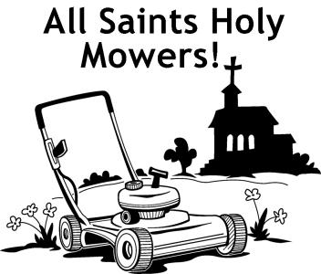

It’s time once again to form teams to mow the church grounds and park thru the summer season. If you can volunteer please sign up at the activities table in the Atrium or see Glen Foster

Celebrate the Resurrection with us by filling the empty space above the doors leading into the Worship Center with crosses! If you have crosses of any shape or size that you would like to donate please tag them with your name and bring them to the church office or give to Glen or Carol Foster

Senior High
Mission Trip

July 5th-11th, 2015 Ripely, TN | Cost: $447
If interested sign up at the Youth table in the atrium

Those Who Serve -Youth News

You may have noticed that there has been a change on Sunday morning. We have transferred the responsibilities traditionally assigned to acolytes to the ushers. The decision to shift these responsibilities to the ushers is to make way for up and coming students to serve in a variety of areas of worship. This fall confirmation students will be trained to serve in several major areas of service during worship: Media shout, running the sound board, and ushering while also being exposed to areas of service where they may serve as skill and maturity allows such as altar guild, praise team/choir, reader, and assistant minister to name a few. I want to thank you all for your continued support and encouragement of this next generation of students as they begin their journeys of service in worship. For further details speak with Kyle Jones.

Easter Breakfast Casserole Potluck
TODAY
between services

We invite our new members to join us and participate in the potluck. Please bring your favorite breakfast casseroles, breakfast breads/pastries/muffins or fruit to share.

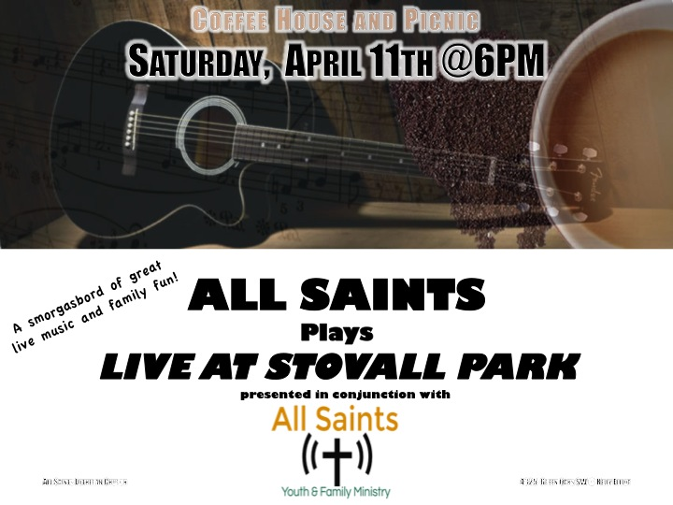

Don’t Miss Out!
Join us at Stovall Park Saturday, April 11th at 6:00pm bring the whole family! Fill up your picnic basket and come sing along with the youth and church band. Bring your lawn chairs. We'll provide coffee and dessert!!

A thank you from a Soldier in the United States Air Force stationed in the United Kingdom:
Hello Kathy and ASLC,
I just wanted to thank you and your church family for all the coupons. It really means a great deal to me and my family that you would support us from so far away. We have saved so much money because of your generosity.
Thank you!
Dwight Jones
USAF

Ladies Meet for breakfast
Thursday, April 16th at 8:45am
At the Corner Bakery on
South Cooper St.

Church
Council Meeting
Thursday,
April 23rd
7:00pm

Church Ministry Boards Meeting
Monday, April 13th 7:00pm
Chick Flick
Friday, April 24th 6:30pm
We will be watching
“Shall We Dance”
starring Richard Gere, Susan Sarandon and Jennifer Lopez
bring a snack!

Men’s Bible Study
Saturday, April 11th
8:00 am

All Saints Lutheran Church
Those Who Serve Us Today
8:45 a.m. 11:00 a.m.
Greeters/Visitor Table: Jerry and Ann Terhune

Ushers: Lynn Davidson
Kay Davidson
Ken Kiesling Dave Gustafson
Rhonda Kiesling Alex Gustafson

Assisting Minister: Marilyn Funderburk

Lay Reader: Marc Funderburk

Altar Guild: Ann Terhune Linda Peterson

Communion Assistants:
Marc Funderburk– Wine Julia Bessler – Wine
Marilyn Funderburk- Wine Lynn Gustafson – Wine
Carol Foster – Bread Curt Lewis – Bread
Pastor John– Bread Pastor John– Bread

Prayer Ministry: Roger McMahon & Susan Parker Mearl & Sue Avis

8:45 Service -Special Musical Accompanists – Pat Brown and Frank Bliss

11:00 Service -Special Musical Accompanist – Ben Marshall

Sound Techs- Steve Bessler, John Barnes
Video – Bill Stephenson
Media – Mary Rosas, Kristen Barnett, Shelby Barnett, Beverly Byers, Alex Byers
Counters: Lauren Beeson Mary Rosas
Coffee Servers: Deb Hanson/Kristen & Shelby Barnett
Nursery Care: Gabbi Inman & Garla Sims
Scrip Table: Carol Foster Vicki Almos

Staff
Pastor: Rev. John Scheusner
Director of Youth and Family Ministries Intern: Kyle Jones
CLC Director: Peggy Elder
Office Manager: Liz Beaty
Contemporary Music/Worship Coordinator: Hedreich Nichols
Choir Director/Accompanist: Joe Alan
Prayer Chain Coordinator:
Vicki Almos
Congregation Council Members
President: Marc Funderburk President Elect: John Viard Treasurer: Dave Gustafson
Treasurer Elect: Jim Kimble Secretary: Libby Lindstrom Secretary Elect: Katie Manquero
Trustee Board Chair: Doug Parker Ministry Board Chair: John Barnes

Congregation Committee Chairpersons
Fellowship: Open Finance: Dave Gustafson Communications: Greg Gearing Community/Member Care: Carol Foster Kitchen Coordinator: Mary Rosas
Outreach/Evangelism: Robin Evans Personnel: Open Property: Len Livingston
Worship Logistics Coordinator: Ann Terhune Youth and Family Ministry: John Viard
Church Office: 817-483-1631 Church Fax: 817-483-8731 Children’s Learning Center: 817-483-6692
All Saint’s Website: www.allsaintsarlington.org Address: 4325 SW Green Oaks Blvd., Arlington, TX 76017
NALC (North American Lutheran Church) Website: www.thenalc.org

